Task 3
Create a new column and display it in cards
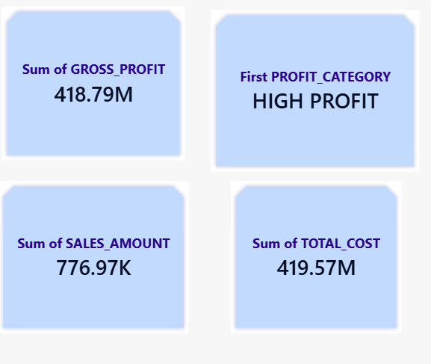
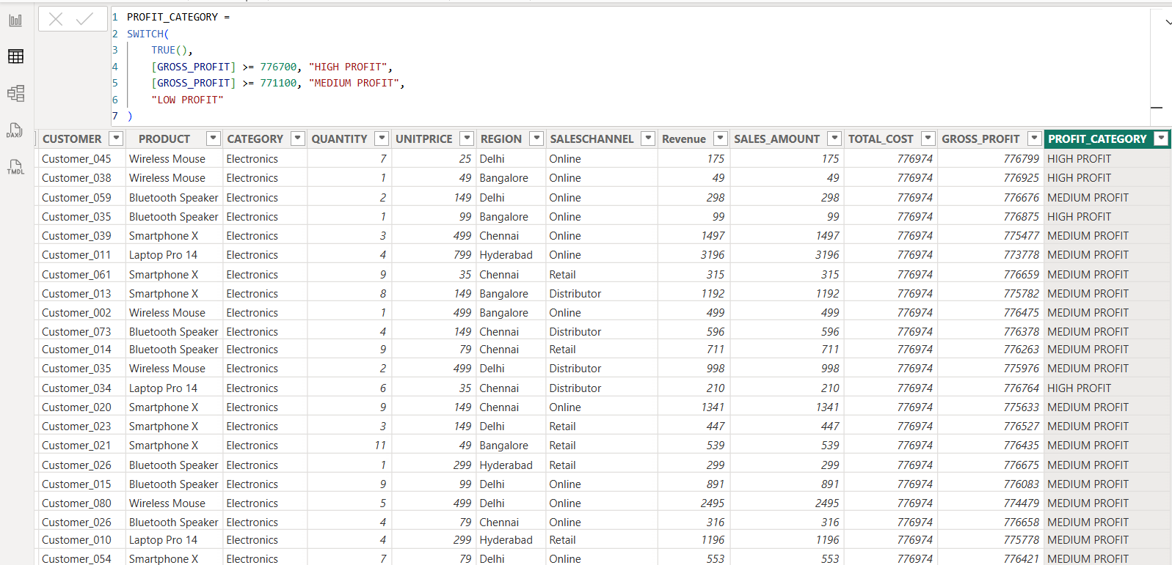

1. SALES_AMOUNT =
SUMX(
SALES_DATA,
SALES_DATA[QUANTITY] * SALES_DATA[UNITPRICE]
)

2.TOTAL_COST =
SUMX(
SALES_DATA,
SALES_DATA[QUANTITY] * SALES_DATA[UNIT COST]
)
3.GROSS_PROFIT =
[SALES_AMOUNT] - [TOTAL_COST]

4.PROFIT_CATEGORY =
SWITCH(
TRUE(),
[GROSS_PROFIT] >= 776700, "HIGH PROFIT",
[GROSS_PROFIT] >= 771100, "MEDIUM PROFIT",
"LOW PROFIT"
)

